PortSwigger Web Security Academy — Proof of Concept

File Upload Lab 2

Web shell upload via Content-Type restriction bypass
Category | File Upload
Lab | Lab 2
Completed By | Security Researcher
Platform | PortSwigger Web Security Academy

Lab Objective
Bypass Content-Type restriction by modifying the Content-Type header to upload a PHP shell.

Step-by-Step Exploitation
- Open Burp Suite and configure browser proxy.
- Navigate to the lab URL and identify the vulnerable functionality.
- Intercept the relevant HTTP request in Burp Proxy.
- Send the request to Burp Repeater for analysis.
- Craft and inject the appropriate payload into the vulnerable parameter.
- Forward the modified request and observe the response.
- Verify the exploit was successful as shown in the screenshots below.

Screenshots & Evidence
Lab Solved — Confirmation
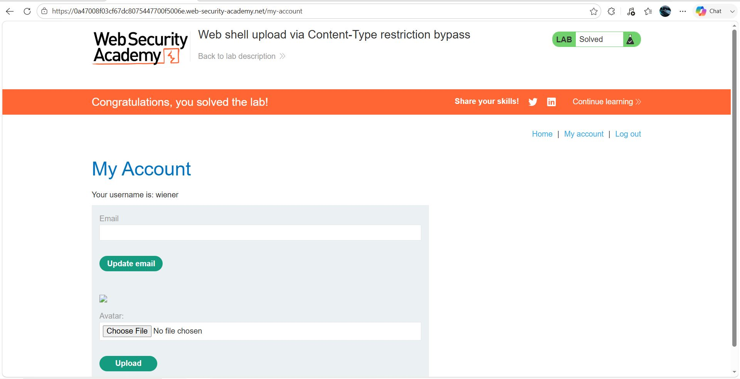
Figure 1: Lab Solved
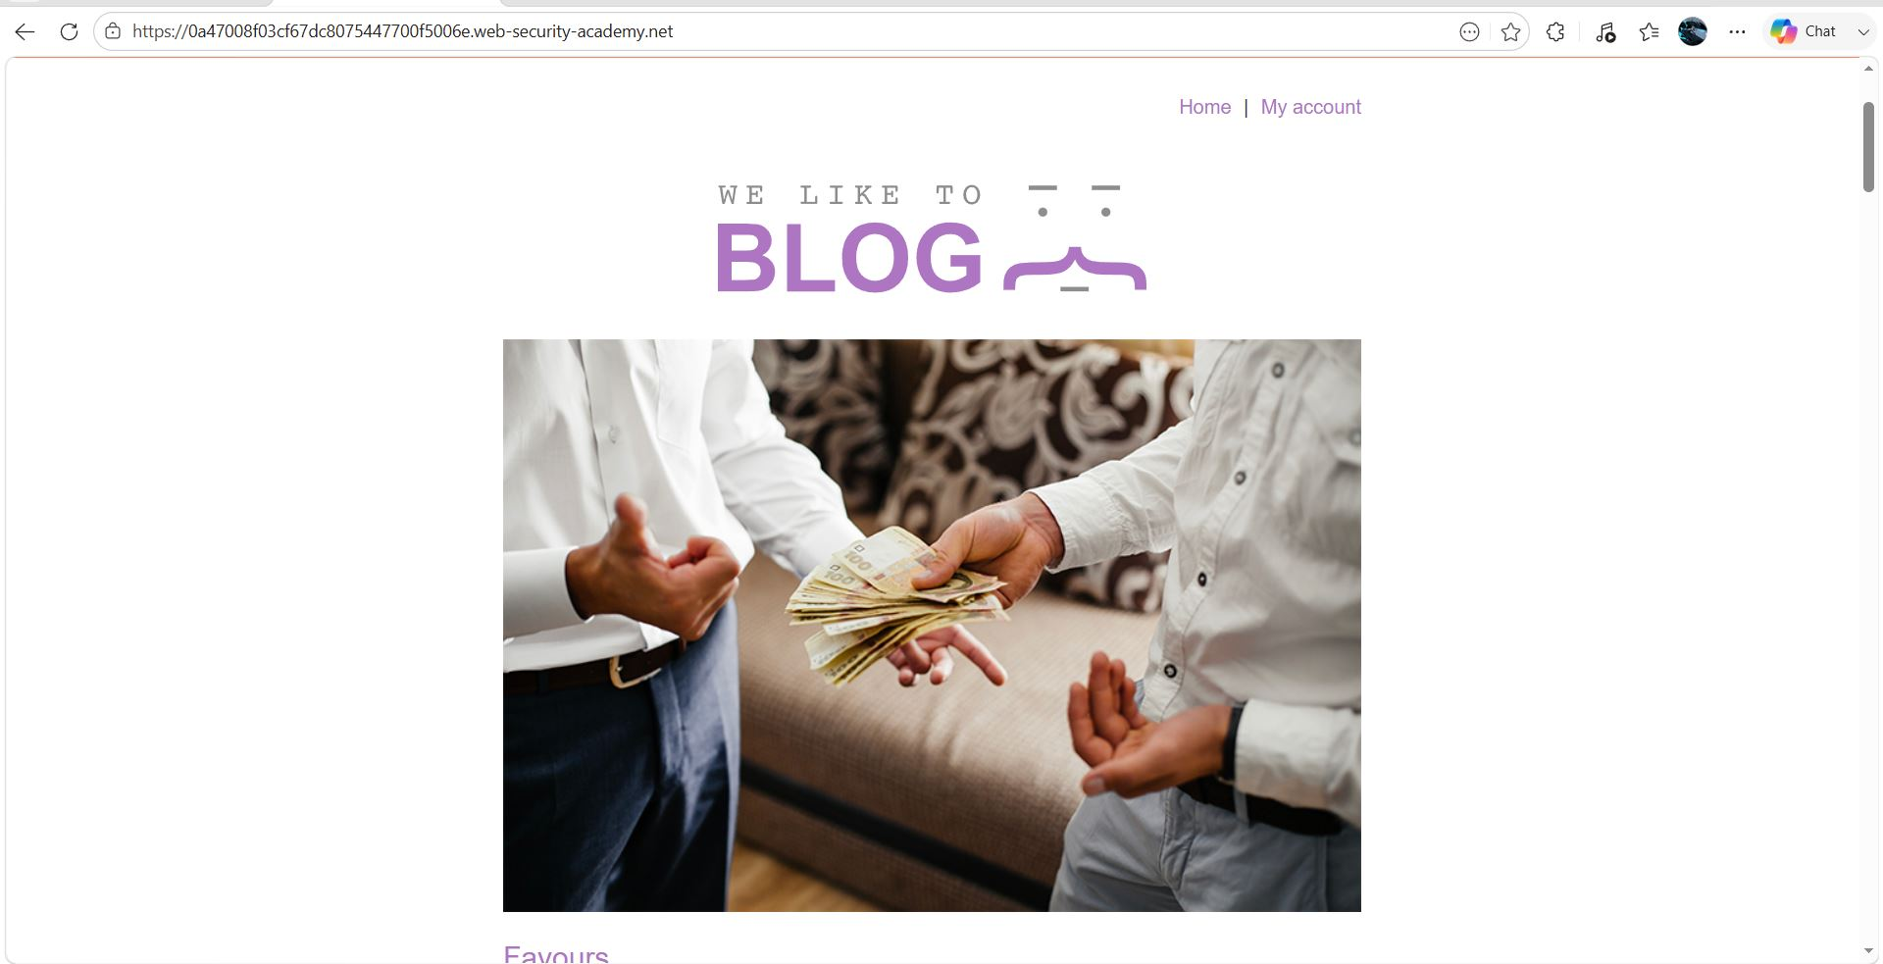
Figure 2: Login Account
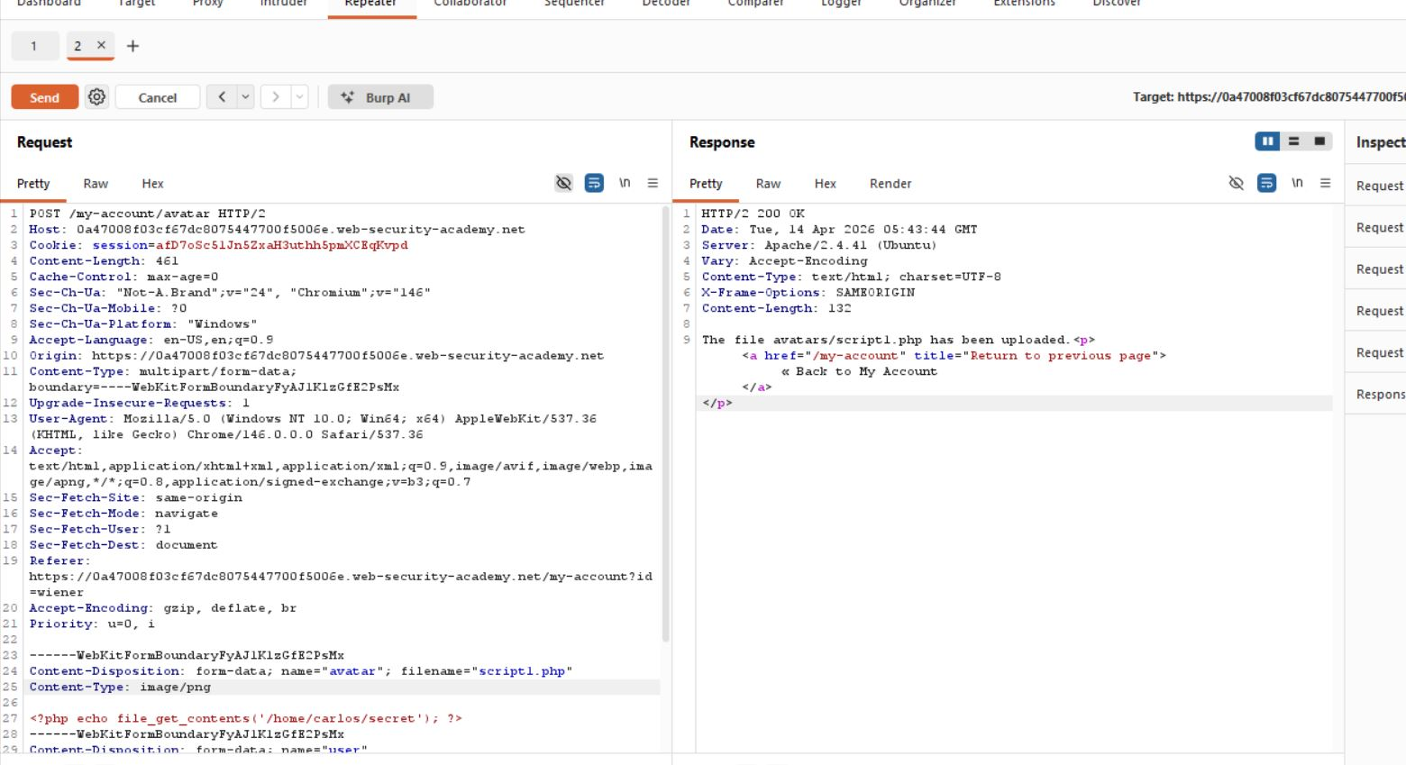
Figure 3: Modify Request
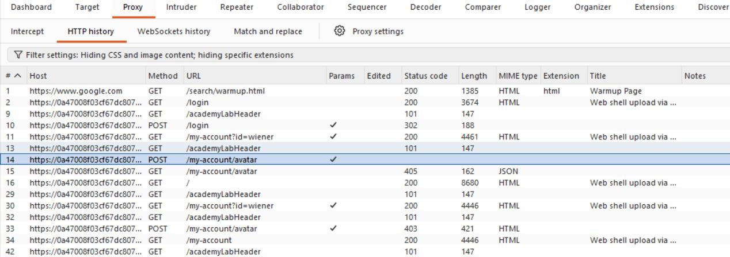
Figure 4: Request Finding
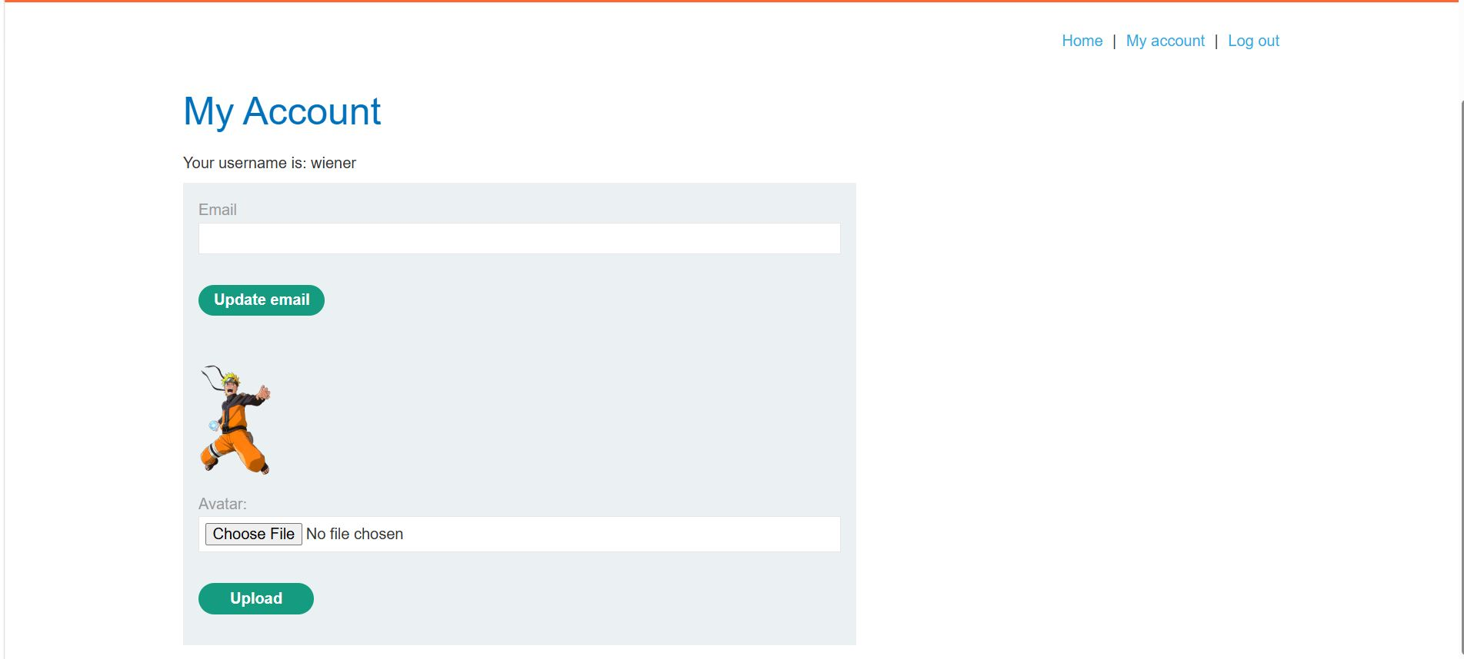
Figure 5: Upoad Image In Account

Lab Status: SOLVED

